**UNIVERSE - REVISION FOR YEAR 10 EXT and ADV - SOLUTIONS**

1. Compare the absolute magnitude and apparent magnitude of a star.

***Apparent magnitude: Measure of how bright a star will appear to an observer on Earth. Brightest stars are given to lowest magnitude.***

***Absolute magnitude: This measures a star’s actual brightness. This measures how bright a star would appear to us if it was a distance of 10 parsec from Earth. Brighter stars have lower magnitudes.***

1. Which unit will you use to determine the distance between stars? ***Light years***
2. What is a light year (l.y.) and an astronomical unit? ***This is the distance light will travel on one year. (9.5 trillion km) AU = distance between sun and earth.***
3. How far is 34.6 light year in km?

***S = 3 x 108 x 365 x 24 x 60 x 60 = 9.46 x 1015 km***

1. i) Which star will be the brightest? Betelgeuse with an absolute magnitude of -5.14 or Bellatrix with an absolute magnitude of -2.72? ***Betelgeuse (-5.14)***

ii) The planet Venus has an apparent magnitude of -4.7 and Jupiter has an apparent magnitude of -2.9. Which is brighter, justify your answer.

***Venus (-4.7) The lower the magnitude, the brighter the object.***

1. Stars emit light at a range of different wavelengths of the electromagnetic spectrum.

Which star will be the hottest, a star emitting mainly blue light or a star emitting mainly red light? ***Blue light will be hottest, it has a shorter wavelength than red.***

1. By using a spectrometer to split light into a spectrum, a scientist can gather two very important bits of information about a star. Name the information that the colour of stars can reveal to scientist.
2. ***It can tell you about surface temperature of a star (cooler stars emit most of their energy in the infrared and red part. Very hot stars emit a lot of energy in the violet and ultraviolet part of the spectrum and appear blue.)***

***ii. Distinctive coloured lines that appear in a star’s spectrum can inform scientist as to the chemical elements present in a star. Elements emit colours of specific wavelengths.***

1. What is the spectral class of a star? ***Spectral class indicates the elements present in a star, the temperature of the star and colour of the star.***
2. The table below shows spectral classes of stars with their associated temperature and colour.

[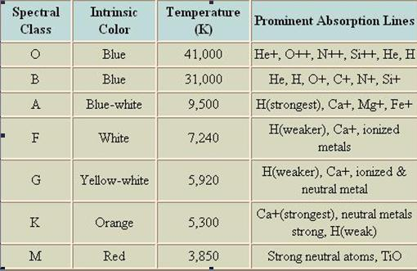](https://www.google.com.au/url?sa=i&rct=j&q=&esrc=s&frm=1&source=images&cd=&cad=rja&docid=9iB-h1VYvd1hIM&tbnid=yWbcKx_VWD9TpM:&ved=0CAUQjRw&url=https://sjhsrc.wikispaces.com/CN%2BMilestone%2BMap%2B-%2BSpectral%2BClasses&ei=o8t5UoaRDMuUkgXGqIGQBg&bvm=bv.55980276,d.dGI&psig=AFQjCNFq-DnJkTAFzBkJzYucd5UEAVODOw&ust=1383800081664222)

* 1. If a star has a temperature of 9750oC what colour will it be? ***Blue-white***
  2. Is a star in a spectral class O brighter than one in G. Explain why you think this is so? (Hint: think about temperature and energy)

***Yes, O will be brighter. Its surface temperature is nearly 7x that of spectral class G. Also blue coloured stars are the hottest.***

* 1. Our sun has a surface temperature of just below 6000o C, what is its intrinsic colour and to which spectral class does it belong? ***Yellow –white and G***

1. Explain how the light inside a star is produced .

***Nuclear fusion of hydrogen atoms into helium atoms generate the initial fuel that will produce the light.***

1. Astronomers have studied the brightness and colour of stars and graphed them on a diagram called a Hertzsprung–Russell diagram. You can see one below. Use this diagram to answer the questions below. Luminosity refers to the absolute magnitude of a star.

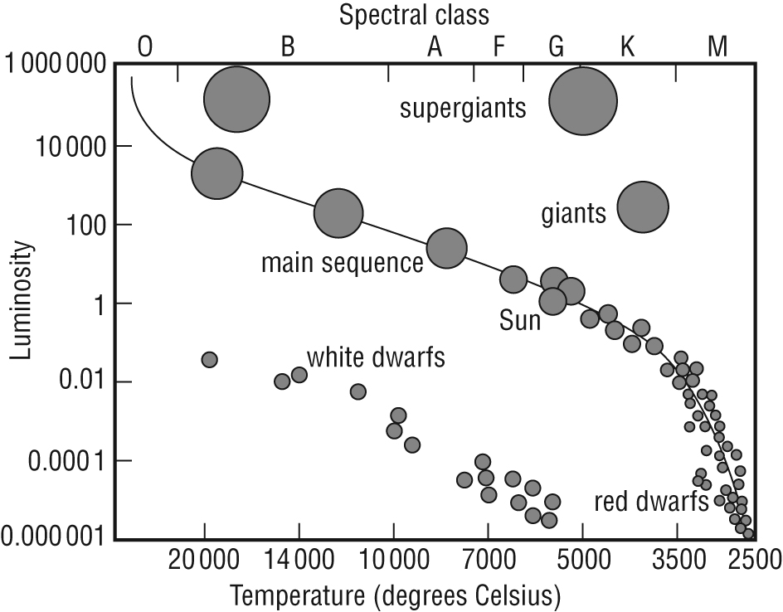

1. To what spectral class does the Sun belong**? G**
2. What does it mean if a star is in the “main sequence?

***Star is in the middle of its lifecycle.***

***Gravity, which causes the material within a star to fall towards the centre of the star, is equal the radiation pressure which is produced by the heat generated by nuclear fusion. This means gravity and radiation pressure are in equilibrium.***

1. Name the forces that are in balance if a star is in the “main sequence”

***Gravity and radiation pressure are in balance (equilibrium)***

1. Explain, using diagrams, the life cycle of a **medium sized star.**

***Refer to text book pg 220 – 224 as well as notes and diagrams in Booklet.***

***Medium size star - red giant – planetary nebula – white dwarf - black dwarf***

[***You need to be able to explain in detail what happens during all of the stages***

***mentioned above.]***

1. Explain, using diagrams, the life cycle of a large sized star.

***Refer to text book pg 220 – 224 as well as notes and diagrams in Booklet.***

***Stars that are 10 or more times as massive as our Sun will follow life cycle below.***

***Large star – supergiant – supernovae - neutron star( supernova remnant 1.4-3 x***

***mass of our sun)***

* ***Black hole (supernova remnant more than 3x mass of our sun)***

[***You need to be able to explain in detail what happens during all of the stages***

***mentioned above.]***

1. Relationship for main sequence stars state: The heavier the mass the brighter and hotter they will be. Why is this so?

***The heavier a star, the hotter and brighter it will be. More mass means greater gravitational force. Greater gravity from large mass causes the star to be more tightly compressed and therefore nuclear fusion occurs more rapidly. Hydrogen is converted into helium more quickly, it will produce more light and heat, but this also means massive star burn up their fuel more quickly.***

1. Do you think stars that are more massive burn up fuel more quickly or slowly?

***More quickly (refer to qu 17 for explanation)***

1. a. What is the difference between a neutron star and a black hole?

1. ***neutron star( supernova remnant 1.4-3 x mass of our sun)***

***Black hole (supernova remnant more than 3x mass of our sun)***

1. Other than the colour, what is the difference between a white and black dwarf?

***A white dwarf is a very dense star and is the remains of a red giant that has faded. It is very hot, but much dimmer than the red giant from which it formed.***

***Nuclear fusion has ceased.***

***Black dwarf is what remains after the white dwarf has faded and become a cold, dark ball.***

1. a. Explain the formation of black holes. ***For supernova remnants that are more than***

***3 x mass of our sun, the great gravitational forces cause the star to shrink into a black hole. Gravitational field of black hole is so strong, that not even light can escape from it. They are very hard to detect as no light escapes from them.***

b. If light isn’t able to escape a black hole. How do we detect for the presence of them?

***1.*** ***Binary star system: When two stars form close to one another and one becomes a black hole, its enormous gravitational force will start to strip material from the other star. As this material spirals into the black hole, it emits a high energy X-ray signal.***

***2. Gravitational lensing: Light form distant stars can be bend if it passes on either side of the black hole. This means the gravitational field of the black hole acts like a lens that can refract (bend) light.***

1. Explain how the red-shift, similar to a phenomenon known as the Doppler effect is used to provide evidence for the “Big Bang” theory.

***Doppler effect: waves produced by moving sources are either lengthened or shortened due to motion of the source. E.g. on approach, sound waves produced by a car will be compressed, therefore having shorter wavelengths and producing a higher pitch sound. For an observer behind the car, the sound waves will be lengthened and the sound will be lower and deeper with a lower pitch.***

***In observing galaxies, Hubble observed that in almost every case, the light observed was distorted giving off a red-colour. This means that the wave lengths were longer, making light appear redder than it should be. This means that universe is expanding as the galaxies are moving away, and therefore it implies that at some point all the matter in the universe was condensed into one point. This represents the birth of the universe , the enormous explosion of energy known as the big Bang.***

1. What is cosmic background radiation?

***Radiation still being emitted after the so called “Big Bang’ which has expanded and has a long wavelength in the microwave range.***

1. With the aid of a diagram, explain how carbon is cycled through the biotic and abiotic components of terrestrial and aquatic ecosystems.

Explanation of the cycling of carbon through terrestrial and aquatic components by referring to each of the steps in the diagram below:

Carbon is stored in the atmosphere, the oceans, living things and fossil fuels.

Plants take in carbon dioxide (CO2) from the atmosphere during photosynthesis.

Plants are eaten by animals and in this way carbon is transferred from air to plants then animals.

All living things release carbon dioxide back into the atmosphere during cellular respiration.

When living things die and decompose some carbon is released back into the atmosphere as CO2.

Some of the carbon is also trapped in the ground.

Fossilization: If the living organism is buried quickly then the carbon can become part of fossil fuels over thousands of years.

During combustion of fossil fuels the stored carbon is released back into the atmosphere as carbon dioxide.

CO2 from the atmosphere dissolves into the oceans by diffusion. This process in increased by wave movement.

Phytoplankton and algae in the oceans take in CO2 during photosynthesis.

Ocean animals consume the phytoplankton and algae and the carbon is transferred to their bodies and become part of protein, fat, DNA (organic compounds).

When living organisms (especially phytoplankton and algae) in the ocean die they can sink to the ocean floor and become buried.

The ocean floor is a carbon sink.

The trapped carbon can form fossil fuels – oil.

The carbon is released into atmosphere again as carbon dioxide during combustion of fossil fuel.

Dead ocean creatures can become compacted forming limestone.

With erosion of limestone - CO2 released back into atmosphere.

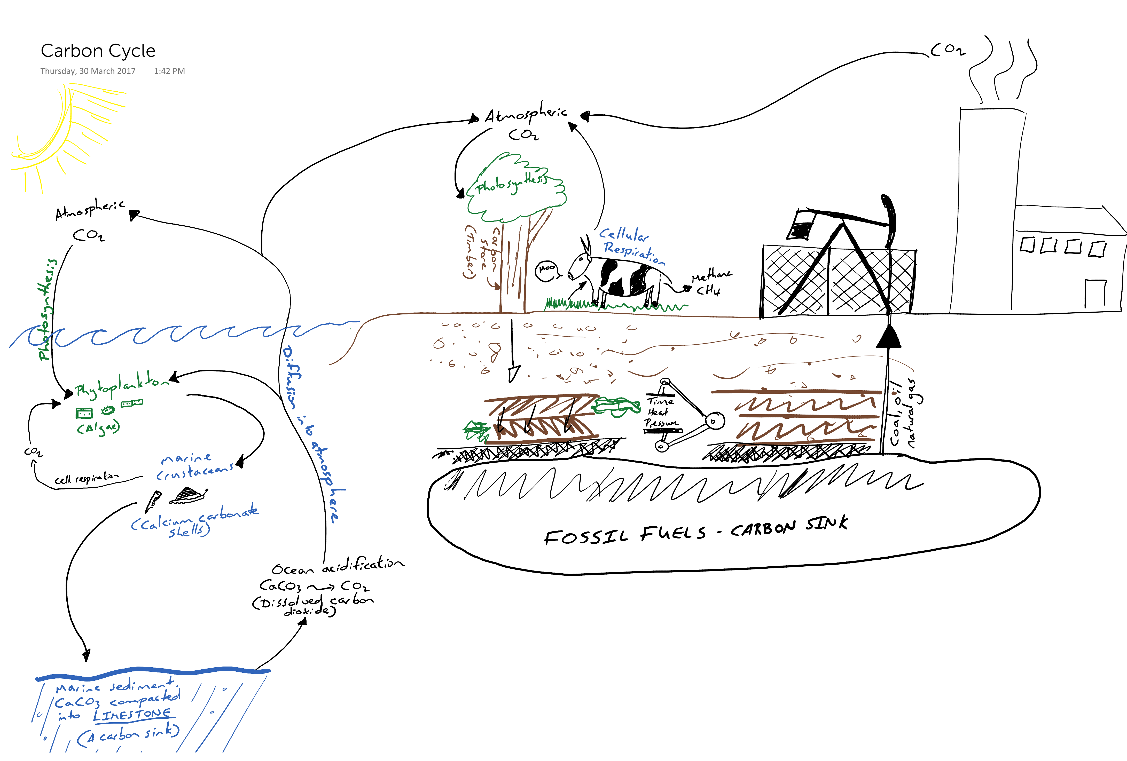

1. Explain the causes and effects of anthropogenic climate change on the earth’s ecology. Refer to the impacts of climate change on coral bleaching and melting ice.

Causes:

* The major cause of anthropogenic climate change is an increase in carbon dioxide, methane and nitrous oxide (greenhouse gasses) in the atmosphere.
* The extra greenhouse gases are primarily due to the burning of fossil fuels (coal, oil and natural gas) and other factors such as land use changes (land clearing, rubbish dumps etc). Methane gas released by herbivores. Nitrous oxide produced by exhaust fumes and use of nitrogenous fertilisers.
* The increasing concentration of these gasses in the atmosphere increase in the natural greenhouse effect beyond atmospheric norms.
* The greenhouse effect naturally protects us from freezing temperatures unsustainable for life, But, an increase in the greenhouse effect can also be dangerous if we cause it to grow too strong.

Effects:

* Greenhouse gasses absorb long wave radiation emitted from the earth and re-radiate it into the atmosphere, thereby preventing this radiation from escaping into space.
* The effect of this is an unnatural warming of the Earth's atmospheric and surface temperature, which affects the following

Coral Bleaching

* Coral nutrition depends on photosynthetic Protista (unicellular algae) that live inside their cells. These Protista provide coral with its colour.
* Slight increase in water temperature will stress coral, they expel Protists.
* Coral loses its colour – becomes bleached.
* Eventually the coral dies because they suffer from lack of nutrients – no unicellular algae to make food for them.
* Approx. 25% of all marine organisms depend on coral reefs.
* The loss of the Great Barrier Reef corals would cause the collapse of an ecotourism industry worth an annual $5 billion, and the loss of a World Heritage listed feature.

Melting

* 1. Permafrost:
* There are vast areas on Earth near the poles where temperatures in the layers of soil and rock in the ground never rise above freezing. These layers are known as permafrost.
* Permafrost traps methane from decaying plants and animals in the ground.
* Rising temperatures cause these layers of soil to melt and release the trapped methane, a potent greenhouse gas with the potential to cause even further global warming.
  1. Polar ice:
* Ice reflects the sun’s rays from surface of earth, this has a cooling effect on Earth.
* Ice covering the ocean waters acts as blanket. Less heat loss from water to atmosphere – essential for survival of aquatic organisms in arctic regions.
* Melting this ice changes the reflectivity of the oceans, warming the oceans thereby increasing the rate of loss of further sea ice.
  1. Sea levels:
* West Antarctic and Greenland Ice sheets are melting. This land ice has the potential to significantly raise sea level if it all melts. Global warming is projected to melt enough Antarctic Ice to raise sea level by 3.3 metres. If Greenland ice sheet melts, global sea level will rise by 7.2 meters.